LAB 2

1- Write a program that takes a number (X) from the user and then prints the value of the following items:

X³ 4^{X}

2- Write a program that converts the weight given in kilograms to the equivalent number of tons.

Example:
Input: 3000
Output: 3

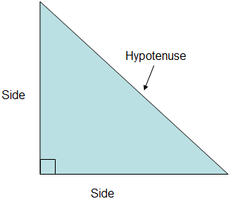

3- Write a program that takes the lengths of two sides and finds the hypotenuse of the right triangle.

Inputs: 7.1 and 12.5
Output: 14.376


4- There are approximately 337692 seconds in a year. Write a program that takes an age in years (from the user) and then prints the equivalent number of seconds.

Example:
Input: 18
Output: 6078456

5- Write a program that takes two points (x1,y1) and (x2,y2) from the user and then prints the equation of the line
y = mx + c passing through these two points,

where the gradient is 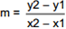 and the constant is c = y1 – m * x1

6- Write a program that rolls two dice and prints the numbers showing on each die as well as the total roll.

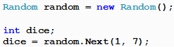

Example:
(There is no any input)
Output:
First die = 3
Second die = 4
Total roll is 7

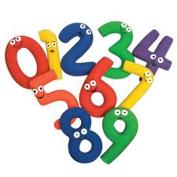
7- Write a program that reads an integer between 1 and 99, then adds the digits in the integer.
For example, if an integer is 93, the sum of its digits is 12.

Hint: 93 mod 10 = 3
(93 – 3) / 10 = 9

